Answers to Chapter 11 HW Questions
- A habitat is a small area where an animal or plant lives.
A biome is a very large area that is made of many habitats and ecosystems. A biome is an area with a particular climate and same types of plants and animals that are adapted to that particular climate.

Biomes | Habitats
- Aquatic (Rivers, Lakes, Ponds, Oceans, Coral Reef) | Pond, Lake, River,
- Tundra | Cave
- Grasslands (Savannah) | Soil
- Desert | Rotted Log
- Forests (Temperate Forests, Tropical Rainforest) | A tree
 | Your back yard

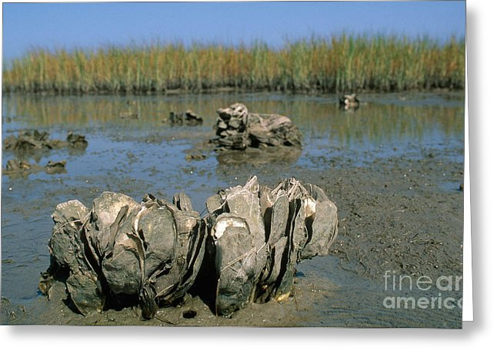
- Biotic Factors are the living things in the environment or habitat.
- Biotic Factors in a pond could be: sunfish, bass, carp, algae, pond weed, duck weed, water lilies, cattails, bullfrogs, tadpoles, yellow bellied sliders
- Abiotic Factors are the nonliving things in the environment.
- Abiotic Factors that might affect an oyster: water pollution, amount of salt in the water, amount of oxygen in the water, the amount of sunlight, the temperature of the water, the water level
- A species – a specific plant or animal; organisms of same species produce an offspring of the same species (example—homo sapiens = a human being)

