Chapter 11 - Section 1—Living Things and the Environment
Read pages 384-388. Answer the following in complete sentences.
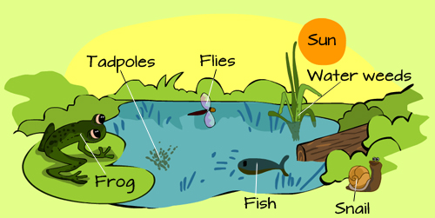
- What is the difference between a habitat and a biome? (Refer to page 442 for information on BIOMES.)
- Can you name 5 different habitats and 5 different biomes?
- What are biotic factors?
- Can you name 5 biotic factors that exist in a pond water habitat?
- What are abiotic factors?
- Name 5 abiotic factors that might affect an oyster or a salmon in its habitat.
- What is a species?
- Can you name 5 different species?
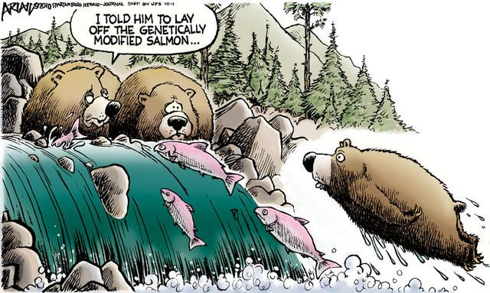
- What is a population?
- Can you give an example of a population of organisms that live in a pond water community?
- What is a community?
- Can you give examples of at least 10 organisms that make up a community in a pond?
- What is ecology?
- What are some adaptions an animal might have for surviving in the tundra biome?
- What are some adaptions an animal or plant might have for surviving in the desert biome?
- Explain the salmon/bear cartoon and how it relates to abiotic factors.

Chapter 11 - Section 1—Living Things and the Environment
Read pages 384-388. Answer the following in complete sentences.
- What is the difference between a habitat and a biome? (Refer to page 442 to obtain information on BIOMES.)
- Can you name 5 different habitats and 5 different biomes?
- What are biotic factors?
- Can you name 5 biotic factors that exist in a pond water habitat?
- What are abiotic factors?
- Name 5 abiotic factors that might affect an oyster or a salmon in its habitat.
- What is a species?
- Can you name 5 different species?
- What is a population?
- Can you give an example of a population of organisms that live in a pond water community?
- What is a community?
- Can you give examples of at least 10 organisms that make up a community in a pond?
- What is ecology?
- What are some adaptions an animal might have for surviving in the tundra biome?
- What are some adaptions an animal or plant might have for surviving in the desert biome?
- Explain the salmon/bear cartoon and how it relates to abiotic factors.

