Creative Connections
- I love it when students take the concepts we learn in class and apply them. I often use the creative products that students build at home for class demonstrations and stations in class. If you are inspired, you are welcome to build an instrument. Try to build one that has the ability to play a simple tune or song such as “Mary Had a Little Lamb”. Build an instrument that can play at least 3 different frequencies.
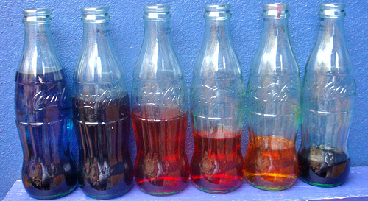
- Build a model that represents a vibrating ear drum.
https://sciencefriday.com/educational-resources/make-a-model-eardrum-to-detect-sound-waves/

