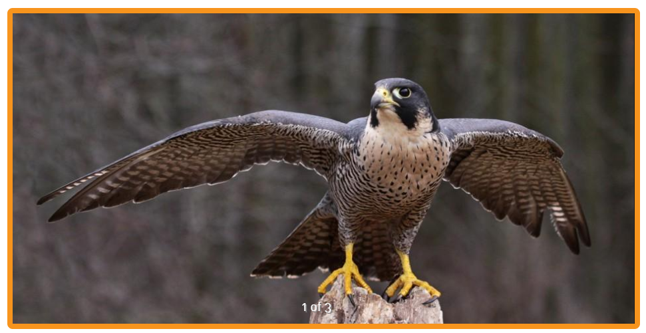
OVERVIEW
Swoosh! A peregrine falcon can dive up to 200 miles (323 kilometers) an hour to capture prey in flight, striking in midair with its outstretched talons, or claws. Peregrines usually hunt with either a swift chase or a fast dive. Starlings, pigeons, and doves are among their favorite meals.
A common bird of prey (a group of hunting birds that includes such birds as hawks and eagles), the peregrine is an adaptable falcon that can be found in almost any habitat. Peregrines live from cold tundra to hot deserts, from sea level to high in the mountains. Their adaptability even allows them to thrive in cities. They live in a greater variety of habitats than almost any other bird of prey. Some peregrine falcons migrate in the winter from their nesting grounds in the Arctic all the way to South America—a round-trip distance of up to 15,500 miles (24,945 kilometers). They make the return trip north when it's time to mate and lay eggs.
Peregrines don't build nests. They usually just find a shallow dip in some rocks or scrape a depression in the soil on the ledge of a cliff, or even use the ledge of a building. Female peregrines lay two to four eggs at a time. Parents incubate the eggs for about a month until the eggs hatch. Peregrine chicks stay in the nest for up to six weeks, by which time they've learned to fly.
Peregrine falcons in the United States were listed as an endangered species after their numbers dropped dangerously low between the 1950s and the 1970s. Certain pesticides used by farmers—including DDT—harmed the peregrines by causing their eggshells to be dangerously thin—so fragile that they broke when the parents tried to incubate them. Laws were enacted to ban DDT and, fortunately the ban, along with other conservation efforts, led to the recovery of the species. In fact, scientists think there now may be more peregrines in some parts of their range than there ever used to be!

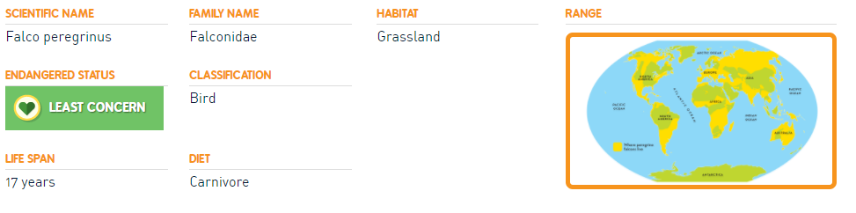

1. What is the effect of the onomatopoeia used in the first line of the overview?

2. How does the peregrine falcon’s vast adaptability help the bird?

3. Explain the bird’s nesting/birthing process in your own words.

4. What was the solution to the DDT problem between the 1950s-1970s?

