Read pages 108-115. Answer the following questions complete sentences.

- Look at figure 1. How are the Sierra Mountains different than the Appalachian Mountains?
- How can you tell that the Sierra Mountains are younger than the Appalachian Mountains?
- *Explain the difference between weathering and erosion.
- Give an example of weathering.
- Give an example of erosion.
- Explain the difference between mechanical weathering and chemical weathering.
- Give 5 examples of how rock can be weathered mechanically. Do not give one word answer. Give explanations in sentences.
- Give 5 examples of how rock can be weathered chemically. Do not give one word answers….you have to explain the processes that occur chemically.
- Look at figure 4. The gargoyles are weathered. Name two things that contributed to their weathering.
- *Describe the 2 things that would cause a rock to weather quickly.
- *Describe two things that might cause weathering to occur slowly.
- *Which climate causes rock to weather the fastest?
- Look at the graph on page 114. Which rock weathered the fastest?
- Since both rock A and B are both limestone, what do you think caused one rock to weather faster than the other?
- What is a permeable rock?
- Look at the tombstones in figure 5. Explain why marble would weather much faster than granite.
- Which tombstone would you prefer (granite, marble, limestone or sandstone)? Why?

Read pages 118-125.
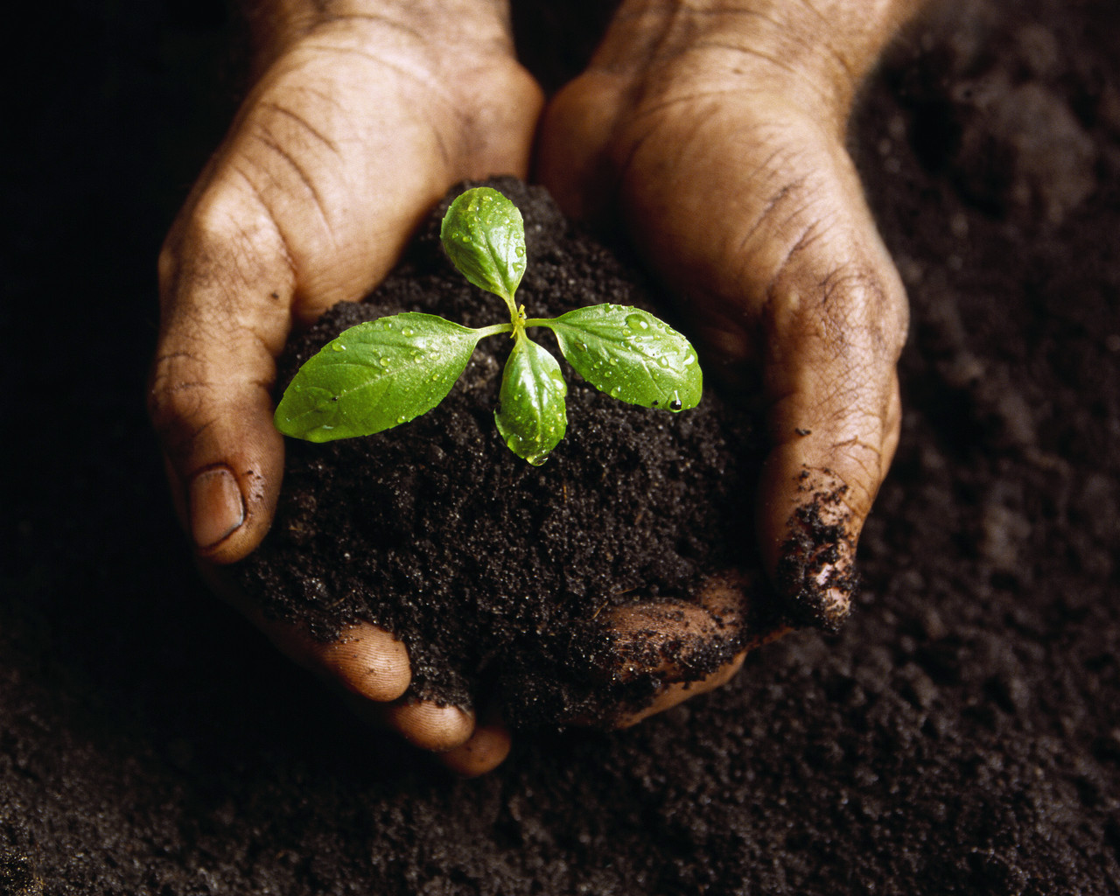

- *How is soil defined?
- *What is bedrock?
- *What five things are often found in soil?
- *What is humus?
- *What is another name for humus?
- *What color is humus and why is it this color?
- *Why is humus important?
- *What does “fertility of soil” mean?
- *Describe a soil that is considered to be fertile.
- *What kind of soil is considered to be infertile?
- *What does soil texture mean?
- *What determines the texture of soil?
- *Draw a chart (figure 7) that gives the size of the particles of soil. Draw the particles and give their sizes in mm.
- *What is loam?
- *Draw, color and label figure 6 – the composition of loam. Color each of the 6 pie pieces a different color. Don’t forget to label all parts and percentages.
- *Is soil mostly made of organic or inorganic matter? Explain your answer.
- *Explain why clay and sand are not considered very good for plant growth.
- *Explain why loam is considered very good for plant growth.
- *What determines how much water soil will hold or drain?
- *Explain how soil is formed.
- *What is a soil horizon?
- *How is topsoil different from subsoil?
- *Describe the climate in which soil forms more quickly.
- *Describe the climate in which soil forms slowly.
- *Would soil form quicker if the bedrock was granite or limestone? Explain.
- Look at figure 9. How many different soils are there in North America?
- Describe the soil that North Carolina has.
- Why do you think Prairie soils are so good for farming?
- Look at Figure 9’s Caption. Name two things that help determine the kind of soil that forms from bedrock.
- Where do the thickest and most fertile soils form?
- *Draw, color and label a soil profile with the following soil horizons: Horizon A (topsoil) / Horizon B -Subsoil / Horizon C - Weathered Rock (Rock Fragments) / Bedrock
- *Explain what decomposers are and give two reasons why they are so important.
- *What are the two most important decomposing organisms found in soil?
- Name 3 ways that earthworms help the soil.

Read pages 126-129.

- *Why is soil considered to be one of the most important natural resources?
- Draw a pie graph that shows the amount of soil on earth that is suitable for farming.
- On average, about how much soil forms in about one century (100 years)?
- Why does it take so long for soil to form?
- *Some soils are said to be exhausted. What does that mean?
- *What is the main way that soils become exhausted?
- *Who was George Washington Carver and how did he contribute to Soil Science?
- *What is the Dust Bowl?
- *Name three things that caused the Dust Bowl.
- *What is Soil Conservation?
- *Describe what Contour Plowing is and how it helps the soil.
- *Describe what Conservation Plowing is and how it helps the soil.
- *Describe what Crop Rotation is and how it helps the soil.
- *What are some things you can do to be a good steward of the soil?


