How do Scientists locate or determine an earthquake’s EPICENTER?
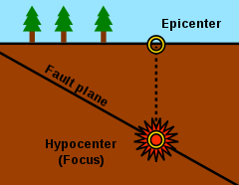
- Read pages 192-193 in your red textbook.
- Use the “Math Analyzing Data - Seismic Waves Speeds” graph and the text to answer the following questions in complete sentences on notebook paper.
1-a. What variable is shown on the x-axis of the graph?
1-b. What variable is shown on the y-axis of the graph?
2. How long did it take the S waves to travel 2,000 km?
3. How long did it take the P waves to travel 2,000 km?
4. What is the difference in the arrival times of the P waves and the S waves at 2,000 km?
5. What is the difference in the arrival times of the P waves and the S waves at 4,000 km?
6. If surface waves were recorded on this graph, how long do you think it would take those to show up on the seismometer (seismograph) at 2,000 km and 4,000 km?
C. Watch the following video then answer the questions in complete sentences.
https://www.youtube.com/watch?v=3eFS4WhsrHA
7. What is the difference between the seismograph (seismometer) and the seismogram?
8. Draw a seismogram. Label where the P waves and the S waves start on the seismogram.
9. What is Lag Time? (Give the definition.)
10. How do you determine the distance the earthquake was from the epicenter using lag time? You can draw a picture if you want.
D. Watch the following video, then answer the questions in complete sentences on notebook paper.
https://www.youtube.com/watch?v=oBS7BKqHRhs
11. How many seismic stations (with seismometers) are needed in order to determine the epicenter of an earthquake?
12. How do scientists determine where the epicenter of an earthquake is? Explain at least 4 steps that scientists take to locate the epicenter.
13. Why is the method for determining the epicenter called the triangulation method?
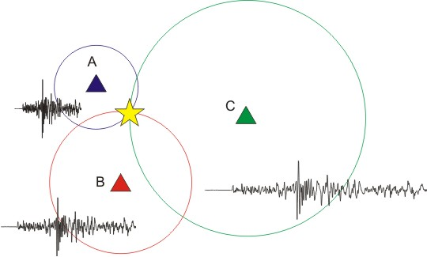
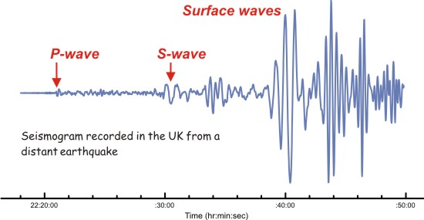
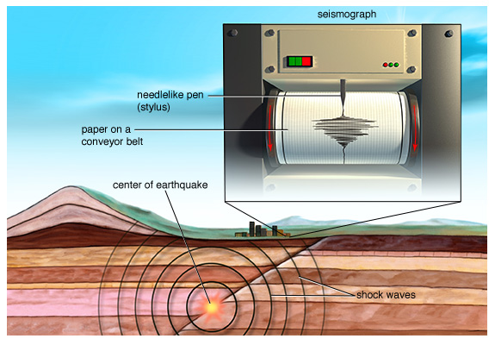

E. Mexico has had several devastating earthquakes in the month of September. Read the following article then answer the questions in complete sentences on the same piece of notebook paper.
http://www.cnn.com/2017/09/20/americas/mexico-two-earthquakes-in-one-month/index.html
14. There was an earthquake that occurred in Mexico on September 8, 2017. What magnitude was it?
15. There was an even more devastating earthquake that occurred in Mexico on Tuesday, September 19, 2017. What was its magnitude?
16. Why was the September 19 earthquake more devastating than the September 8th one if the September 8th earthquake was stronger with a higher magnitude? (Critical Thinking Question-Look at the diagrams, read the text, think and collaborate with your partner to come up with the answer.)
17. Why are scientists not surprised that several earthquakes are occurring near one another and within the same month in Mexico?
18. Was the Tuesday, September 19th earthquake a shallow or deep earthquake and what was the depth of the focus or hypocenter?
19. Which earthquakes (shallow or deep) are more devastating? Explain why you think they are more devastating.
20. 80% of earthquakes occur along the Ring of Fire. What two plates were involved in the earthquake that struck Mexico on September 8 and 19th?
21. Which 5 tectonic plates are involved in the most unstable area along the Ring of Fire?
22. Was the September 19th earthquake an aftershock of the September 8th earthquake? Explain your answer.
23. Why was it not possible to predict the earthquake and save lives?
24. What is the best way to protect people in the future from earthquakes?

