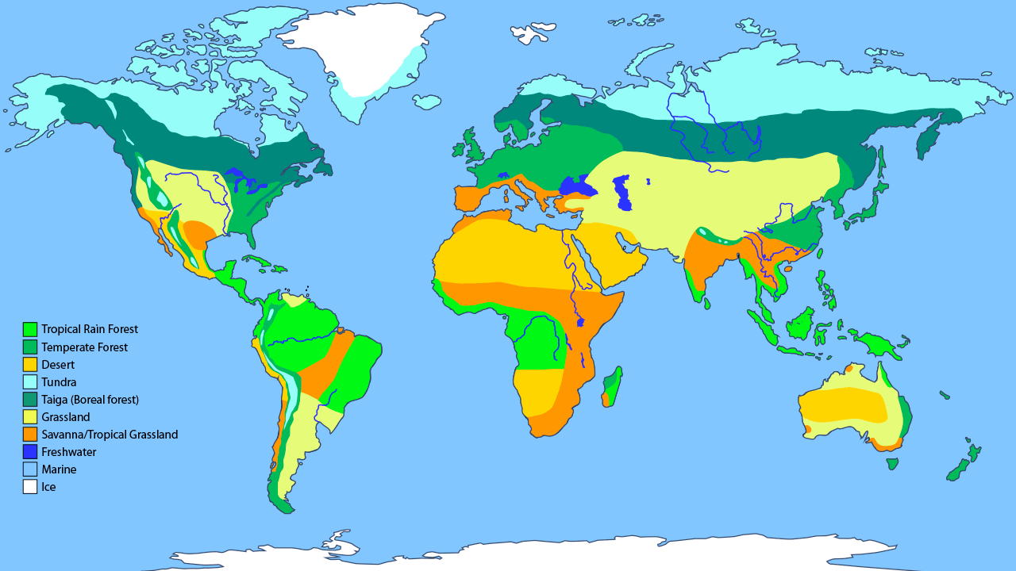

**Class Copy**

**World Biome Map**