Religion | Judaism | Christianity | Islam | Hinduism | Buddhism
What is the major belief about God/gods?
What do you call a person who follows this religion?
Who is the important figure (leader)?
What is the holy book called?
Where do people worship?
Where is the place of origin?
Where are the holy cities?
Major symbol for the religion | 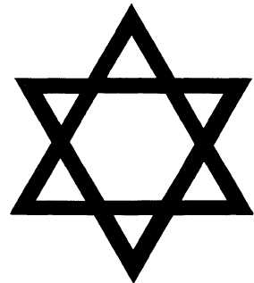 |  | 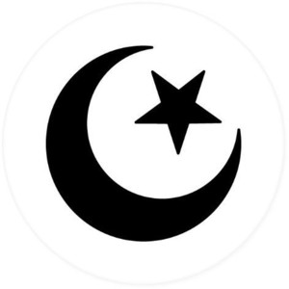 | 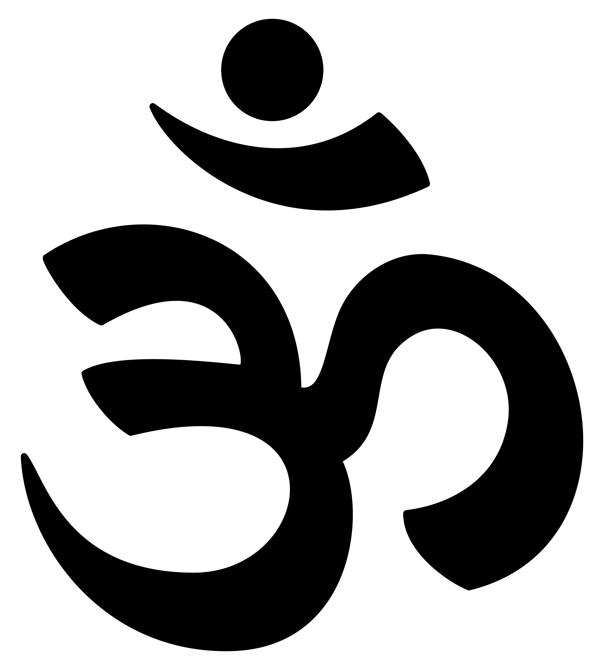 | 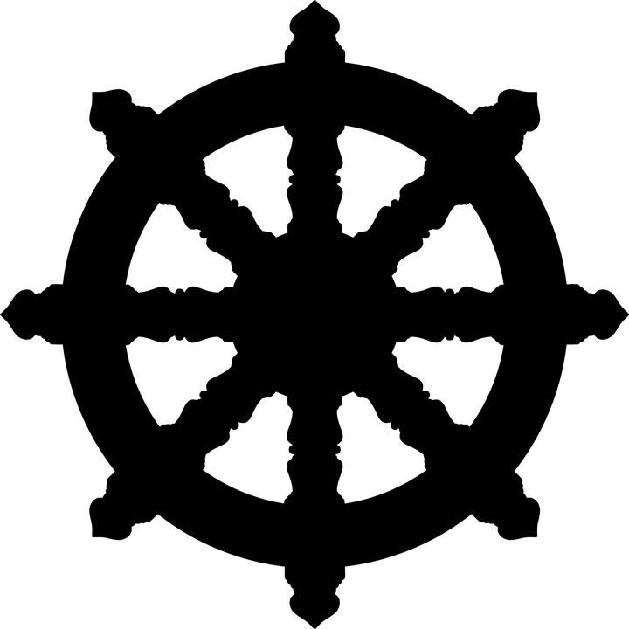
What do you notice about the similarities and differences between these world religions?

