**Sedimentator (Sediment Stick)**

Air bubbles and a few Organic Particles (dark)

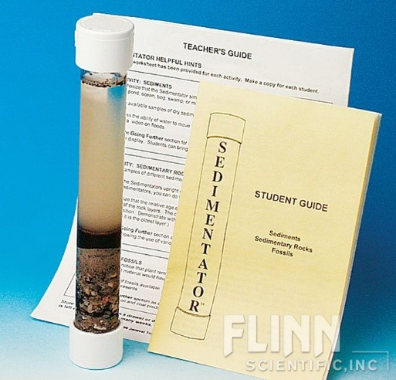

Suspension – water with tiny sediment particles suspended in it. Could have clay and silt particles suspended in it.

Humus (Organic Matter)- this layer is made of things that used to be alive so it is very dark in color. (Dead leaves, twigs, grass, animals, animal waste, insects etc.)

Sand- this is an inorganic sediment so it is lighter in color.

Rock fragments or gravel sink to the bottom. They are the most dense particles. Gravel is lighter in color because it is an inorganic sediment,

**~CLASS COPY~**

1. Sediment = small pieces of weathered rocks, plants and animals.
2. Sediment can be made of both living (organic) and non-living (inorganic) matter.
3. Organic sediment (used to be alive) is often called Humus and is very dark in color (sometimes black).
4. Inorganic sediment (not alive and never was) is lighter in color (usually tan).
5. Organic Sediment Examples= leaves, twigs, roots, grass, pine straw, bark, dead animals, dead insects, animal waste etc.
6. Inorganic Sediment Examples = rock fragments, pebbles, sand, silt, clay
7. The most dense sediment particles settle to the bottom.
8. The least dense sediment particles float on top of the water.
9. Sediment forms when rocks are exposed to the weather (wind, water) etc. This is called weathering. Weathering breaks rocks down into smaller pieces.
10. Sedimentary rocks form when the sediments get compacted and cemented together over a long period of time.
11. Soil is made of broken down (weathered) rocks, plants and animals. So soil contains these sediments.