Soil Horizon Formation:
- The C Horizon (Rock Fragments) forms first as the exposed bedrock at the earth’s surface weathers and breaks into rock fragments.

- The A Horizon forms second as plants and animals living at the surface die and decompose to form Humus or Topsoil.

- The B Horizon forms last (or third) as rainwater washes clay and minerals from the topsoil downward through the soil to form subsoil. When the water moves through the soil pulling clay and minerals with it this is called Leaching.

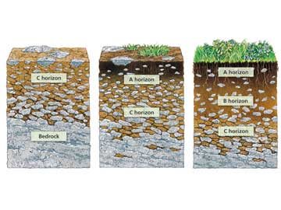
The B Horizon forms last as rainwater seeps through the ground pulling clay and minerals down to form the subsoil layer.
A Horizon forms second when the plants and animals die and decompose to form topsoil or humus.
C Horizon forms first as the bedrock weathers into rock fragments.

The way I remember the horizon formation order is to remember the word CAB.

