South Asia Study Guide

1. Describe the geography of South Asia and how it impacted the way people lived there.
______________________________________________________________________________________________________________________________________________________
__________________________________________________________________________________
__________________________________________________________________________________

2. Define the following terms:
- Indus River: _________________________________________________________________
- Monsoon: ___________________________________________________________________
- Subcontinent: ________________________________________________________________
- Himalaya Mountains: __________________________________________________________

3. Who is Ashoka (Asoka) and why is he important?
______________________________________________________________________________________________________________________________________________________

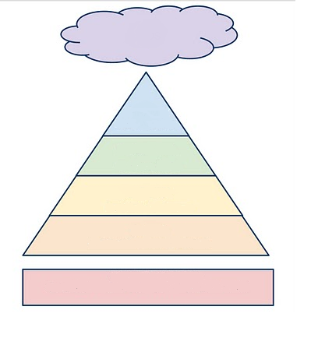
Caste System
4. What is the Caste System?
_____________________________
_____________________________
_____________________________

5. What are some rules that classes must follow?
_____________________________
_____________________________
_____________________________

6. Fill out the following chart to show the levels of the Caste System and examples of individuals who would be in each level.

Hinduism : Identify the following terms related to Hinduism.

7. Reincarnation:_____________________________________________________________
8. Karma: ___________________________________________________________________
9. Vedas:___________________________________________________________________

Buddhism
10. Siddhartha Gautama is also known as the _______________.

11. How did Siddhartha Gautama’s life lead to the development of Buddhism? _______________________________________________________________________
_______________________________________________________________________
_____________________________________________________________________________

12. The _______ _________ _________ and ____________________ ____________ are the path to enlightenment in Buddhism.

13. Buddhist believe _____________ is the state of perfect peace, with no more suffering and the end of rebirth.

Harappan Civilization

14. What evidence was there that the Harappans were an advanced civilization? _________________________________________________________________________________________________________________________________________________________________________________________________________________________________

