Triple Venn Diagram Assignment

- Use the following website to research the similarities and differences between the three major religions we have studied this year: Judaism, Christianity, and Islam.
- http://primaryhomeworkhelp.co.uk/Religion.html
Judaism
Christianity
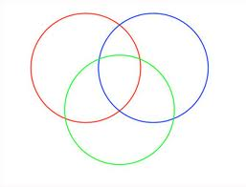
Islam

