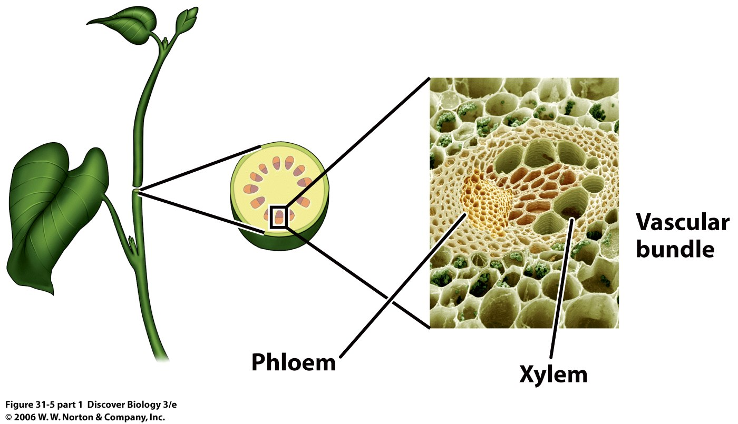

**~Class Copy~**

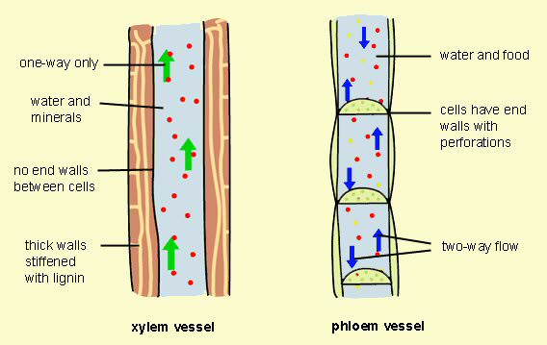

Plants have two different types of transport tissue. **Xylem** transports water and solutes from the roots to the leaves, **phloem** transports food from the leaves to the rest of the plant. **Transpiration** is the process by which water evaporates from the leaves, which results in more water being drawn up from the roots.